*********************************************************************

S I G N A L S

 |  | Monthly Newsletter of the
 | Amateur Radio Club

Volume 37 Issue 10 Web Site http://www.w5rok.us July 2016
*********************************************************************

RCARC
Membership Meeting

Tuesday 26 July 2016
1700 Social 1730 Meeting
1800 Program

Methodist Richardson Medical Center
At Bush/Renner/Shiloh Intersection
Conference Room A in Hospital Building

Subject:
Radio Program Loads & Interfacing
by Bob Kirby K3NT
Local Club News
Meeting Notice
At the June meeting, unless he is deployed, plans to present a talk on the older Ham Radio Deluxe (HRD) and the latest Fast Light Digital modem application (FLDGI) digital programs for PSK-31, RTTY, CW etc., that he has installed on his Win 7 station laptop in the past month. Bob reports that he HRD interfaced and successfully working with the Kenwood TS-2000. The FLDGI program is decoding digital data and he hopes to have the radio control going soon.
Location: RCARC has RESERVED Methodist Richardson Medical Center Conference room A or B for the RCARC monthly meeting, (fourth Tuesday of each month) from April, 2016 through August, 2017. Each reservation is for 5PM to 8PM. We are welcome to stay longer if the room has not been reserved for a later time.
Directions: The new meeting location is in the hospital. No longer will we be meeting in the Doctors Building; we now meet in the main hospital building. To find your way for the first time enter by the main entrance on the south side of the hospital. Stay on the first floor and turn left at the entrance and go down the hall to where it just turns to the right heading for the emergency room; do not continue. Turn left and go into Conference Room A.
RCARC Community Service Activities
Siren Testing Dennis Cobb WA8ZBT, John McFadden K5TIP and Jim Skinner WB0UNI participate in the Richardson emergency siren testing. The testing on 6 July 2016 was successful with the possible exception of one siren that was not monitored due to late arrival of its observer. The siren testing is performed at 12:00 on the first Wednesday of each month. The sirens are monitored by amateur radio operators and reports made using the Richardson Wireless Klub (RWK) repeater at 147.120 MHz. Siren testing occasionally uses the University of Texas at Dallas (UTD) repeater at 145.430 MHz, which is designated as the backup repeater.
Crime Watch Patrol Jim Skinner WB0UNI participated in Richardson Duck Creek Crime Watch Patrol (CWP). CWP members, after successful completion of Richardson Police Department Training, patrol their neighborhoods and report all suspicious activities to the Police Department.
A Demand for Transparency at the American Radio Relay League
James Wades, United States
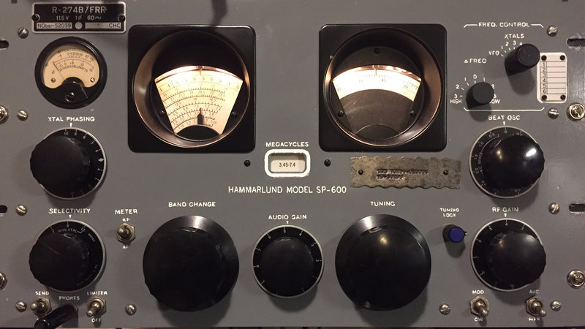
The American Radio Relay League is a 501(c)(3) non-profit organization for radio amateurs (Continued on page 3)

RCARC OFFICERS
PRESIDENT |  |  |  |  |  | VICE-PRESIDENT
OPEN |  |  |  |  |  | Gene Duprey |  | K1GD
 |  |  |  |  |  | 319.270.8159
 |  |  |  |  |  | geneduprey2015@gmail.com
SECRETARY |  |  |  |  |  | TREASURER
Jim Brown | AF5MA |  |  |  |  | Mike Montgomery |  |  | WD5TX
972.495.2209 |  |  |  |  |  | 972.705.1498
jhksbrown@verizon.net |  |  |  |  |  | dmmontgo@rockwellcollins.com.
ACTIVITIES CHAIRMAN |  |  |  |  |  | WEBSITE MANAGER
Bob Kirby |  |  | K3NT |  |  | Mike Hollingsworth |  |  | W5QH
319.360.0500 |  |  |  |  |  | 972.571.6060
k3nt@arrl.net |  |  |  |  |  | w5qh@arrl.net
STATION TRUSTEE |  |  |  |  |  | NEWSLETTER EDITOR
Steve Phillips |  | K6JT |  |  |  | Jim Skinner | WB0UNI
972.517.3332 |  |  |  |  |  | 214.535.5264
k6jt@arrl.net |  |  |  |  |  | wb0uni@arrl.net
MEMBERSHIP |  |  |  |  |  | W5ROK CLUB STATION
Joe Wolf |  |  | N5UIC |  |  | 972.705.1349
214.202.2757 |  |  |  |  |  | 461-290
n5uic@arrl.net

VE SESSIONS
Dallas tests are held on the fourth Saturday of each month at 1000 hrs. 13350 Floyd Rd. (Old Credit Union) Contact Bob West, WA8YCD 972.917.6362
Irving tests are held on the third Saturday of each month at 0900. Fifth and Main St. Contact Bill Revis, KF5BL 252-8015
McKinney VE test sessions are held at the Heard Museum the first Sunday of the month. The address is 1 Nature Place, McKinney TX. The time of the testing is 1430, ending no later than 1645. Note: no tests given on holiday weekends.
Garland testing is held on the fourth Thursday of each month, excluding November, and begins at 1930 sharp. Location is Freeman Heights Baptist. Church, 1120 N Garland Ave, Garland (between W Walnut and Buckingham Rd). Enter via the north driveway. A HUGE parking lot is located behind the church. Both the parking lot and the Fellowship Hall are located on the east side of the church building, with big signs by the entrance door. Contact Janet Crenshaw, WB9ZPH at 972.302.9992.
Plano testing is on the third Saturday of each month, 1300 hrs at Williams High School, 1717 17th St. East Plano. Check Repeater 147.180+ for announcements.
Greenville testing is on the Saturday after the third Thursday, 1000 hrs at site TBA, contact N5KA, 903.364.5306. Sponsor is Sabine Valley ARA. Repeater 146.780(-) with 118.8 tone.

Richardson The Richardson Wireless Klub (RWK) VE team hold license testing on the third Thursday of each month at St. Barnabas Presbyterian Church, 1220 West Beltline Rd. Testing begins at 1900 hrs in room 12. Enter through the Northern most door on the east side of the church building. For further information contact Dave Russell W2DMR, at 972.690.9894 or E-mail warhog4 @tx,rr.com.
SIGNALS is the monthly newsletter of the Rockwell Collins Amateur Radio Club, published by and for its members. The entire contents of this newsletter are copyright © 2016 by the Rockwell Collins Amateur Radio Club. Permission is hereby granted to any not-for-profit amateur radio publication to reprint any portion of this newsletter provided both the author and Rockwell Collins Amateur Radio Club are credited.
President and VP Messages
Well the Summer is now in full swing, Hamcom is over and Field Day (FD) also. I did not participate in FD this year as I just have had too many things on my plate over the past several months. But next year for sure. Hamcom had some highs and some lows. Most of the manufacturers were there, but I was disappointed by the Kenwood booth, which was a table with about 5 radios set up. But I did not see any reps from Kenwood and there was no literature. Also the ARRL seemed on a budget this year as they had no books or other items at their booth for sale. There were however, quite a few antenna people there with samples and products to sell. Another one that caught my attention was the FlexRadio Systems booth. They had a full 4 radio station setup to give demos & for people to try out. Quite an impressive system, and the Maestro remote unit is quite nice. Also high on my list was the setup at the Elecraft booth, with their KX3 unit.
With the weather getting warmer, we are getting a car port put up at the house and this will give me some more room to maybe finally get my G5RV dipole up. I will finally be back on the HF bands! Well that's all for now, see you at the meeting.
73's
Gene, K1GD

Secretary's Report
28 June 2016
The meeting was called to order by Gene Duprey K1GD at 1752.
The following were present at the meeting:
Jim Brown AF5MA
Dennis Cobb WA8ZBT
Gene Duprey K1GD
Bob Kirby K3NT
Mike Schmit WA9WCC
Jim Skinner WB0UNI
Joe Wolf N5UIC
The meeting began with a discussion of experiences at HamCom by Gene Duprey K1GD and a summary of Field Day activities by Dennis Cobb WA8ZBT. Despite poor atmospheric conditions the event was a success, including a Field Day dinner at the ham shack for members and families.
Officers and Committee Reports:
There were no formal reports other than the Secretary's Report, which is contained in this newsletter.
Old Business:
There was no old business.
New Business:
New business discussions addressed the need to upgrade club radio equipment and proposals for doing so. Bob Kirby K3NT proposed buying a second Elecraft K3 Transceiver to replace an aging Kenwood FT2000/TS2000 to achieve, among other things, a much lower synthesizer noise floor. Purchase of the K3 would include purchase of companion equipment P3 and KAT500, retaining use of current filters.
Dennis Cobb WA8ZBT suggested buying just the "basic station" (K3, P3) for now, and volunteered to obtain prices to support further discussion at the next meeting.
Adjournment:
The meeting was adjourned at 1822, followed by a program by Bob Kirby K3NT on N1MM software for field day logging.
A Demand for Transparency (Continued from page 1) dedicated to public service, advocacy, education, technology and membership. The organization is supported with membership dues and is governed by a Board of Directors elected by the membership.
Recent questionable events, as well as an on-going lack of transparency, have caused significant concern amongst members. Board of Directors meetings are conducted behind closed doors. Programs and Services Committee meetings are conducted behind closed doors. Executive Committee meetings are conducted behind closed doors. Detailed financial data is extremely difficult to obtain.
Recently, the Section Manager for Eastern Pennsylvania was removed from office by the Executive Committee without any form of due process or consultation with the members. Worse yet, a press release was issued, which was untrue and clearly designed to be a personal attack. These vindictive and unprofessional actions have exposed the organization to significant financial liabilities (see the case “Ames vs. American Radio Relay League,” which is pending in Federal Court).
We, the undersigned members and former members of the ARRL who have resigned in protest wish to express our extreme dissatisfaction with the “star chamber” methods of governance and significant lack of transparency within OUR representative organization. In particular, we demand:
- Open Board of Directors meetings
- Open Programs and Services Committee Meetings
- Open Executive Committee meetings
- Annual publishing of a detailed budget identifying the application of funds to specific programs and operating interests.
- On-the-record voting at Board of Directors meetings.
- Audio recordings of the above meetings, which are made available to members via the web page.
- Rules preventing “off the books” meetings of elected officials and corporate officers.
The ARRL is broken. It’s ours. Let’s fix it. WE DEMAND TRANSPARENCY!
This petition will be delivered to: ARRL Board of Directors
(Reprinted courtesy of www.change.org. Contributed by Steve Phillips K6JT)
Presentations for Monthly RCARC Meetings
RCARC has an urgent need for presenters to present a short topic on Ham Radio at our monthly club meetings. 45-60 minute Presentations may include, but are not limited to:
- Set-up, Building or Modifying Station Equipment (Antennas, Audio, Dummy Loads, Desks, Lights, ...)
- Operating a Radio Station (Listening & Transmission tips, Ham Logo decrypted, Popular Frequencies, ...)
- My Radio Broke (Possible Alternatives before using the Sledge Hammer, ...)
- Different types of Digital Operation (APRS, Packet, PSK 31-64, RTTY, ...)
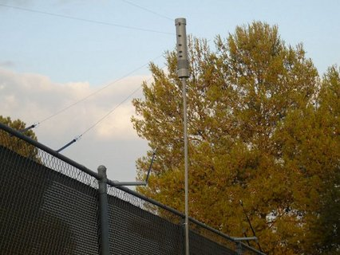
- Software Defined Radios (Commercial, Kits, Remote, Internet, ...)
- Software used for Ham Radios (WSPR, PSK-31, ...)
- Emergency Radio Equipment (Go Kits, Batteries, Solar power, Easy-Up Antennas, ...)
- Ham Radio Activities (MARS, RACES, MARC, Contests, Satellites, Mobile, Portable, Remote, Field Day, SWL, ...)
- Radio Reference (On-line manuals, theory, how to books & Videos, ...
- Social Mingle (With light snacks? Ham and cheese crackers? ...)
If you would like more information on a particular topic, and would like someone to do a presentation on it, you may suggest it as a topic. Please email Bob Kirby K3NT, Jim Skinner WB0UNI or Gene Duprey K1GD to present a topic or to suggest a topic for presentation.
Let's try this out while supply lasts. Any RCARC member who presents a program or lines up and follows through with a speaker/presentation (including timely advanced bio and program description to Mr. Skinner) will receive a VHF (or UHF) commercial grade antenna along with a commercial grade magnetic mount with coax cable for each completed program. The speaker will also receive like antenna and magnetic mount/coax cable.
Please note: Simply passing along program prospects or leads, while highly appreciated by your radio club, does not count towards the antenna and magnetic mount with coax offer. However, you may be eligible for a hunk of pre-RF'ed feed line for your pet to chew on. In the absence of said pet, it just could become your "Pet Coax".
The Fence Fan Dipole (FFD): A Quick, Easy and Inexpensive Multiband Antenna
from Howard Groveman, W6HDG on March 14, 2016
Background
The multiband fan dipole has always been a popular antenna choice for getting on several bands with a single feedline and without the need for an antenna tuner. The height is limited only by the nearest tall tree and the cost of the antenna is minimal. The antenna is also rather stealthy – especially if 16-18 gauge wire can be used in sub 200 watt installations. The antenna basically consists of two to five or more distinct half wave dipoles which are mounted to a common parallel feedpoint so that a singe feedline can be utilized. Some nice designs are easy to find on the internet or in antenna handbooks. Most designs now suggest (based on Stanford Research Institute data) that the feedpoint be separated by as much as 5.5 inches between dipoles and that the lower frequency (longer) dipoles can be about 4% shorter than the 468/frequency in Mhz would dictate whereas the higher frequency (shorter) dipoles need to be about 4% longer. Many designs also recommend the controversial “ugly balun” choke in the design which is nothing more than 18-21 feet of coax close wound on a 4” or greater non-conductive form at the feedpoint.
There are certain downsides of the traditional fan dipole in that the top wire must often support the entire weight of the antenna as well as the balun. The need to ideally spread out the feedpoints by up to 5.5 inches also makes the feedpoint area rather cumbersome. Complicated spreaders must also be used in order to keep each dipole taut and well separated when there are only 2 end attachment points. There also can be some interaction among the dipoles and some detuning may occur if a dipole is included which is a frequency multiple of 3 from a longer dipole in the system (3rd harmonic). For example a 30 meter, 15 meter and 6 meter ½ wave dipole may not be possible if an 80 meter, 40 meter and 17 meter dipole exists. A possible match may be obtained on 30 meters, 15 meters and 6 meters using the existing longer dipole but testing is required. Finally, it is difficult to trim and tune the antenna, since a single rope or rope-pulley system supports the entire array and it must be completely taken down for wire tuning or repair.
Objective
I am just getting back on HF after a few year hiatus and have moved to a neighborhood with some antenna restrictions. My rig is a Yaesu FT-857D and Astron 30 amp power supply. I have no tall trees on the property but do have one large feature on the property – a 45 year old tennis court with 12 foot fencing all around it. Each long side of the fencing is 120 feet total (a nice sounding number to dipole fans).
I decided to try an inexpensive antenna design as a starting point “just to get on the air”. I figured that if I lashed a 10 section of schedule 40 PVC pipe to a central fence support with hose clamps, I could get an inverted-V up at around 20 feet at the center (not an ideal height for DX, but certainly usable). I then figured that I could use the dipoles themselves as “guys” for the central support if at least two of the dipoles were attached on a short offset support on both sides of the fence. The other dipoles could be “bungeed” directly to the fence mesh to keep them taut.
The advantages of my Fence Fan Dipole (FFD) design is that just about any sturdy fence that spans the linear distance of the lowest band can be used. The center feedpoint and balun can be made from a single two foot section of 4” drainpipe with end caps for weather resistance. This could be attached and supported atop a central PVC support pipe with appropriate threaded plumbing adapter and an electrical metal threaded nut available at most hardware stores. See construction images below. Each dipole is separately lashed to the fence with a bungee-like tarp strap so individual band tuning does not require entire antenna takedown. Dipoles can be easy attached and changed at the retention/ relief posts along the drainpipe for testing, experimenting and possible future repairs. Finally, excellent spreader distances between dipoles at each endpoint can be achieved.
Construction
RG-8X coax and PL-259 connectors with adapters were the only ham radio specific parts.
The remaining parts were all obtained during a couple of trips [to] the nearest Home Depot:
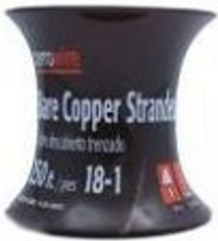
1) 18 gauge bare stranded copper “ground” wire is about $17 for 250 feet and worked extremely well. The 250 feet was just a few feet short for all dipoles so I made my 17 meter dipole from heavier bare copper stranded antenna wire I had on hand. If any of the copper is tarnished, it can be quickly rejuvenated by soaking in a few of ounces of vinegar with a half teaspoon of salt added. This allows the copper to be solder-ready in the necessary spots.
2) Two foot section of 4” ABS drain pipe with 2 end caps
3) Ten foot section of 1 inch schedule 40 PVC with threaded PVC adapter and a metal retention nut sold in the electrical section for threaded pipe. Three hose clamps to attach the PVC to a vertical member of the fence post
4) Copper clad plumbing strapping, copper electrical lugs with setscrews (Burndy KA4CBAG2R), Ten ¼ inch x 1.5 inch eye bolts, two solder lugs for coax attachment, ten ¼ inch lock washers and a total of twenty ¼ inch nuts (ten of which are included with the eye bolts)
5) Four short 18 inch pieces of PVC to be use as fence “guy” standoffs along with four U-Bolts for attachment – see close-up image.
6) Ten tarp straps (bungee cords)
7) 10 Plexiglas rectangles prepared from a single 12”x12” sheet of 1/8” Plexiglas. Each rectangle about 3 inches by 1.5 inches with holes drilled on each long end.
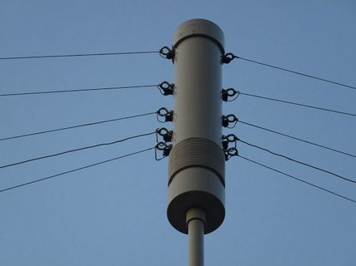
Construction is quite straightforward if you study the images beleow. I separated the 80 and 40 meter dipole eyebolts by the full 5.5 inches. I compromised and separated the 40 and 20 meter dipoles by 4.5 inches, 20 and 17 meter dipoles by 3.5 inches and the 17 and 10 meter dipoles by 3 inches. Each of two copper clad straps run the length of eyebolts along the inside of the ABS pipe. The coax lugs are attached at the eyebolts closest to the “ugly balun”. Lock washers are used between the interior nut and the copper strapping. The balun itself is about 16 turns of RG-8X (21 feet) with epoxy used to seal the two inlets. The RG-8X then runs down the inside of the PVC support pipe. I used a barrel SO-239 at the bottom of the support pipe for convenience. I painted the coax, the ABS pipe and PVC all brown to keep things stealth.
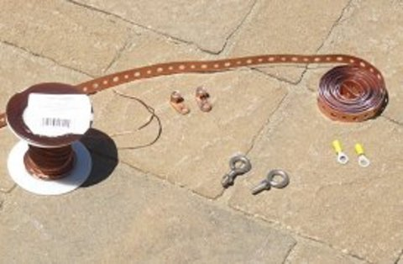 | 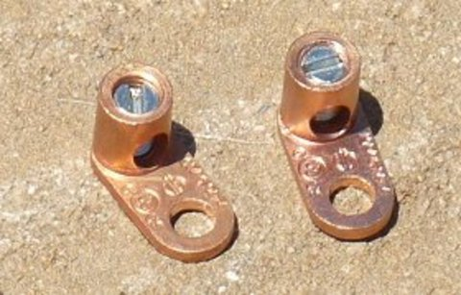
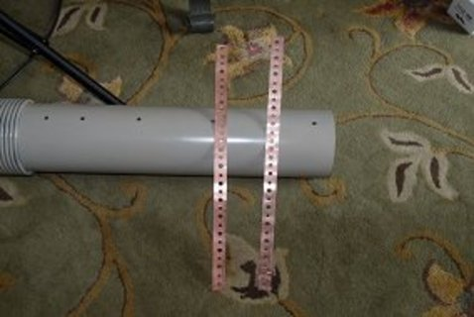 | 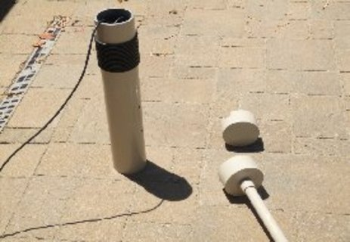
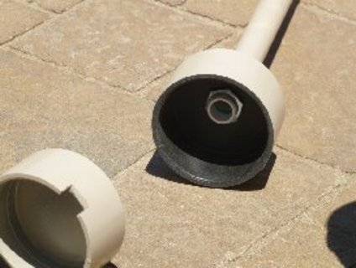 | 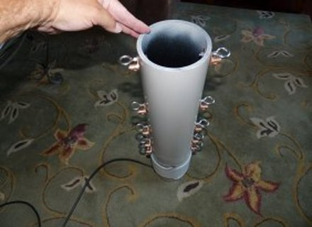
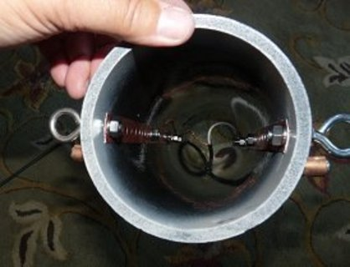 | 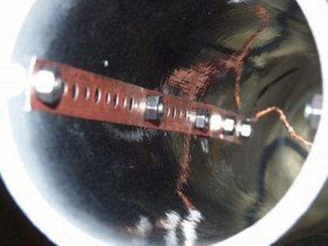
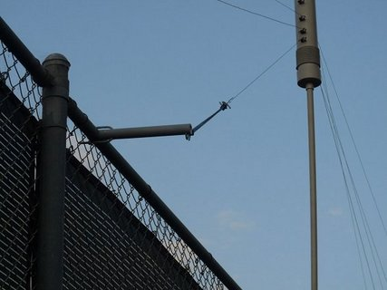
A note about using two of the dipoles as “guys” to keep the flimsy PVC support pipe upright: If I had bungeed all dipoles to the fence mesh itself, I would not have had support in the “Y” plane to keep the PVC support pipe upright. I could have used two opposing rope guys for this purpose, but didn’t want to have any ground mounted supports. So I fashioned 18 inch fence top extenders by grinding a corresponding arc in an end of a piece of PVC and used a U-Bolt through the PVC to create a sturdy standoff from the fence. Good “Y” plane support can be achieved by bungeeing two of the shorter dipoles on each side of the fence with these extenders. This has kept the central PVC pipe quite vertical with resistance to winds we have seen to date.
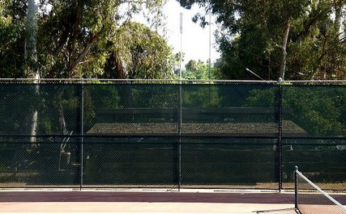
The completed antenna is so stealth, it is quite hard to photograph. Hopefully this image with give you a good idea of the appearance of the support and at least of 3 of the 5 dipoles.
Dipole lengths, after adjusting some of the dipoles with the help of an MFJ-259 antenna analyzer were approximately:
80 meters : 61 feet each side including the loop between setscrew and eyebolt
40 meters: 32.8 feet each side including the loop between setscrew and eyebolt
20 meters: 17 feet each side including the loop between setscrew and eyebolt
17 meters: 13.6 feet each side including the loop between setscrew and eyebolt
10 meters: 8.6 feet each side including the loop between setscrew and eyebolt
Results
The FFD has obvious downsides – non-portability, height compromises and possible interaction with the fence if it is metal.
But initial testing has been quite good. During an hour of operating the IARU HF championship July 14-15, 2012, I worked 6 countries on 4 bands including Aruba, South Cook Island, Japan, Argentina, Canada and Mexico.
The antenna has acceptable SWR on 80, 40, 20, 17, 10 and 6 meters and contacts were made on all bands without an antenna tuner. 15 meters is usable.
SWR results were as follows:
3.8 Mhz 1.9 (SWR was 2.5 at 3.70, 2.5 at 3.9 and 3.8 at 4.0)
7.2 Mhz 1.3 (SWR was under 2.0 across entire band except 2.6 at 7.00)
14.13 Mhz – 1.0 (SWR was under 1.5 across entire band)
18.14 Mhz – 1.0 and same across entire band
21.3 Mhz – 2.9 and same across entire band
28.5 Mhz – 1.2 (SWR was under 2.0 across entire band except 2.2 at 29.7)
52 Mhz – 1.4 (SWR was under 1.8 across entire 4 Mhz of the band)
I may add a tuner to get a better match on 15 meters and more bandwidth on 80 meters. It is unclear if a dedicated 15 meter dipole would have worked fine or if there would have been detuning - I haven’t tried it.
I have no illusions about DX worthiness of this antenna. But dipoles and inverted-V’s can make good antennas – especially on the lower frequencies where multi-element antennas are not practical. The multiband variety of the dipole such as that described here, when well tuned, should not suffer appreciably in performance over a monoband dipole at similar height. The advantages of a single feedline cannot be overemphasized.
References
A Field Guide to Simple HF Dipoles, Cecil Barnes, et al, Standford Research Institute, Mar 1967, see
http://www.scribd.com/doc/50272493/A-FIELD-GUIDE-TO-SIMPLE-HF-DIPOLES
KJIIF, “The KJ4IIF Multiband "FAN" Dipole for 160, 80 and 40 Meters”, see
http://www.hamuniverse.com/kj4iif1608040fandipole.html
N4UJW, “BUILD THIS MULTIBAND FAN DIPOLE FOR ALL BAND HF ANTENNA EXCITEMENT”, Sept 2010, see
http://www.hamuniverse.com/multidipole.html
Paul Coats, AE5JU, Morgan City, LA "From Shortwave Listener to Extra Class" - http://www.hamuniverse.com/ae5jumultibanddipole.html
March 2013 Update to the Fence Fan Dipole
I have been very happy with the Fence Fan Dipole I first erected in July 2012, but wanted to increase the height of the central support above the original 20 feet. I had also received a few reports of some RF in my transmit audio and decided that I wanted to add a real 1:1 balun at the feedpoint.
The “Ugly Balun” choke type balun using coax windings is great for a single band antenna, but the number of turns determines its effective choke frequency – so it is impossible to cover 80 through 6 meters with one coil of coax. I had heard wonderful reports of the baluns designed by the late Jerry Sevick W2FMI. These designs were now being made by Mike Lapuzza, KM5QX who runs Clear Signal Products at website www.coaxman.com. Mike was kind enough to make a special version of his 823A balun without the eyebolts so that it would fit inside my PVC drainpipe (see original article). This fit inside the pipe at the same location where the external coax windings were removed. The balun worked like a charm and I have since received nothing but great audio reports – even after adding an Elecraft KPA500/KAT500 amp/tuner combo to my station. Mike hand makes the baluns, so he is very open to special orders like mine.
In researching lightweight support poles, I found John at http://goverticalusa.com. John sells new and used surplus military style fiberglass and aluminum 4 foot mating mast sections. The aluminum and fiberglass poles can be used in combination and fit together perfectly. To get to my goal height of 36 feet, I decided to use 6 stiffer aluminum sections for the lower mast and 3 fiberglass sections for the upper mast. My reason for using fiberglass was so that there were no metal sections at the top to interfere electrically with the dipoles. John also makes a very nice guy ring which can be inserted at any joint in the sections.
I placed the guy ring at 24 feet so that I could guy the mast at that point using some Dacron rope. I fashioned two additional ¾ inch PVC outriggers to the fence to support the ropes from this guy ring in a 360 degree fashion (see final antenna picture). Remember, my lowest 12 feet of mast was solidly supported by hose clamps along the 12 foot high tennis fence. At the top (36 feet), the antenna would be “guyed” in the same way it had always been, by attaching the dipoles to the fence top with tarp style bungee straps (using some PVC outrigger poles at the fence top to keep the antenna balanced at the vertical). With the increased height, I now needed to add some Dacron ropes to some of the dipoles to fan them out properly along the fence.
The result has been worth the effort. The only downside of the increased height is that the entire mast would need to be lowered for any work to be done on the antenna’s individual dipoles. You can’t tilt over 36 feet of military poles without damaging them, so the antenna must come down the same way it went up – by removing (adding) one section at a time from the bottom as you slide the pole down (up) through the loosened hose clamps. Not very elegant but doable with a couple of people.
Since the original article was published, several hams have written with positive experiences. One ham fashioned 8 dipoles with one feedline for multiple bands including 15 meters and said that he did not have an issue with both a 40 and 15 meter dipole coexisting (3rd harmonic could cause both dipoles to potentially radiate). So experimentation is the name of the game with this antenna design.
Howard W6HDG
Upcoming Events
AUGUST
20-21 | 10 GHz & Up – Round 1 The objective of 10 GHz and Up is for North American amateurs work as many amateur stations in as many different locations as possible in North America on bands from 10-GHz through Light. Amateurs are encouraged to operate from more than one location during this event. See the detailed rules for restrictions. Operations may take place for 24 hours total on contest weekend. The weekend begins at 6:00 AM local Saturday though 12:00 midnight local Sunday. Details at http://www.arrl.org/10-ghz-up.
21 | Rookie Roundup – RTTY Mission: To encourage newly-licensed operators (“Rookies”) in North America (including territories and possessions) to operate on the HF bands and experience competitive Amateur Radio operating. Experienced operators (“Non-Rookies”) are strongly encouraged to participate and help new operators – either on the air or in person. Objective: Rookies exchange information with as many other stations as possible on the 80, 40, 20, 15, and 10 meter HF bands. Rookie entrants are encouraged to read “HF Contesting – Good Practices, Interpretations and Suggestions.” Operation is from 1800 UTC through 2359 UTC. Details at http://www.arrl.org/rookie-roundup.
REGULAR ACTIVITIES
Daily | DFW Early Traffic Net (NTS) at 6:30pm 146.88 – PL 110.9Hz
Daily | DFW Late Traffic Net (NTS) at 10:30pm 146.72 – PL 110.9Hz
Daily | Texas CW Traffic Net (NTS) at 7:00pm on 3541 KHz and at 10pm on 3541 KHz www.k6jt.com
1st Wednesday | Richardson Emergency Siren Test. At noon using the Richardson Wireless Klub (RWK) repeater at 147.120 MHz.
2nd Wednesday | ARES North Texas HF Net Every month—3860 KHz at 8:30 pm—9:30pm

Rockwell-Collins
Amateur Radio Club
Mail Station 461-290
P.O. Box 833807
Richardson, TX 75083-3807

TO:

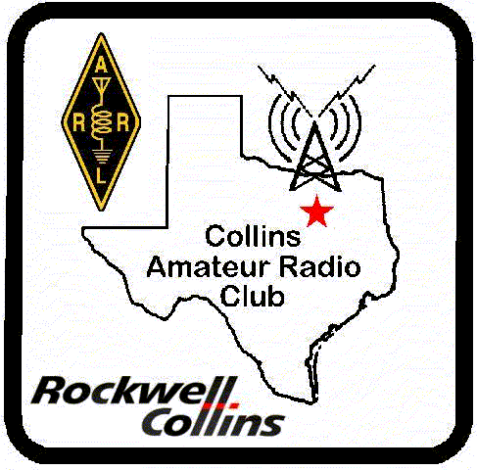 | CLUB STATIONS  (972) 705-1349  W5ROK REPEATER  441.875 MHz +5 MHz Input  131.8 Hz PL - RX and TX  W5ROK-1 PACKET BBS ROK Node  145.05 MHz  W5ROK-N1, W5ROK-N2 & W5ROK-N3 HSMM-MESHNET Nodes 2.4 GHz
Tuesday 26 July 2016
1700 Social 1730 Meeting
Methodist Richardson Medical Ctr
At Bush/Renner/Shiloh Intersection
Conference Room A in Hospital Building

NEXT SIGNALS INPUTS DEADLINE:
➔➔➔ 12 August 2016 ⬅⬅⬅

