*********************************************************************

S I G N A L S

 |  | Monthly Newsletter of the
 | Amateur Radio Club

Volume 28 Issue 11 Web Site http://www.collinsclubs.com/rcarc/ August 2007
*********************************************************************

RCARC
Membership Meeting

*Thursday*
*23 August 2007*
1730 in
Rockwell Cafeteria

Subject: Tornados! Tornados! and more Tornadoes!
Local Club News
Meeting Notice This months meeting will feature a video on tornado(e)s (spell it either way and spellcheck will be happy—after all it does rhyme with potato(e)s). The timing is perfect since we are in the midst of the tornado season, The video has pictures of tornados from quite a few years and many states, including some film from the Dallas 1957 twister. So, all you storm chasers and potential storm chasers, be sure to attend. And be sure to read the article to the right.
Club Meeting Talk-In Each month, we have a Talk-In on the club repeater before the membership meeting on the night of the meeting. The Talk-In is from 1700 to 1730 hours, just prior to the meeting.
ARRL UHF Contest Results W5ROK operated in the ARRL UHF Contest August 4 and 5, 2007. W5ROK operated about 3 hours during the 24 hour contest. W5ROK had 24 contacts in 10 different grids on 432 MHz and 11 contacts in 5 grids on 1296 MHz. The results were submitted to the ARRL.

Forecaster finds thrills in the chase By Bryon Okada, Star-Telegram Staff Writer
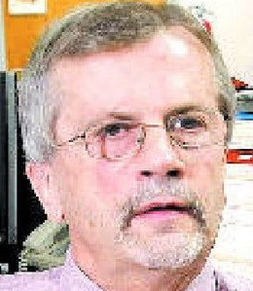Allen Moller | 
FORT WORTH -- Maybe it was the night his mother died.
It was 1954, Alan Moller was 4 and the family was driving from Fort Worth to Indiana when the car wreck happened. The rest of the family wasn't hurt, but Marion Moller was killed. That night, as the grief sank in, Moller remembers the severe storms -- thunder crashing over and over, as churning supercells rolled in from the northwest.
"Something just clicked," he says.
Since that night, the storms have never left him. It seemed then, as it still does, that the mysteries of life and death are somehow wrapped up in them. After his mother's death, Moller would often sit on the flat roof of his father's house and stare up at the open sky, wondering why things are the way they are.
"What is this cloud?" he asks, even now, remembering the nights of his youth. "Why is it white during the day and red in the evening?"
Eventually Moller would find scientific answers to those questions. He would become a prominent meteorologist in the North Texas area. But he retained an understanding that there were subtle aspects to his chosen specialty -- tornadoes and other severe storms -- that would forever be beyond his grasp. In a way, his colleagues say, that humility brings him more credibility.
"Al is comfortable talking, not only about what we know, but what we don't know," said Bill Bunting, meteorologist in charge of the National Weather Service's Fort Worth office. "He'll be the first person to tell you he's not an expert -- but he's an expert."
The easy admission of fallibility makes him approachable, an ideal characteristic for a federal agency that often relies on spotters recruited from the local community for its on-the-ground information.
For Moller, however, it's been about chasing down moments -- the stormier the better.
Chasing storms
In 1957, when a deadly F3 tornado hit downtown Dallas, he was already obsessed. The 16 miles of destruction was well-documented on film. It made him dream of seeing the power of a tornado personally.
On May 4, 1960, he sat on his father's roof and watched an F3 tornado cut a 7-mile swath across Tarrant County -- a path 500 yards wide northeast of Fort Worth that injured 12 and caused $250,000 in damage -- one of the strongest tornadoes in the county's history. And he wanted to get closer.
After graduating from Paschal High School, Moller went to (Cont. on Page 3)

R-CARC OFFICERS

PRESIDENT
Bill Swan |  |  | K5MWC
462-300 |  |  | X3441
hwswan@rockwellcollins.com

VICE PRESIDENT
Bob Kirby |  | K3NT
 |  | 319.360.0500
k3nt@arrl.net

SECRETARY
Jim Gaston |  |  | KD5GYD
 | X3369
jrgaston@rockwellcollins.com

TREASURER
Jim Skinner |  |  |  | WB0UNI
214.535.5264
wb0uni@arrl.net

ACTIVITIES CHAIRMAN
Dennis Cobb |  |  | WA8ZBT
462-240 | X1457
wa8zbt@arrl.net

WEBSITE MANAGER
Wayne Hughes |  |  | WA0TGH
461-258 |  |  | 1406
wa0tgh@arrl.net

REPEATER TRUSTEE
Steve Phillips |  |  | K6JT
972.517.3332
k6jt@arrl.net

CLUB STATION
972.705.1349 |  |  | W5ROK
461-290

NEWSLETTER EDITOR
Jim Skinner |  |  | WB0UNI
972.690.9612
wb0uni@arrl.net

VE SESSIONS
Dallas tests are held 4th Sat of each month at 10:00. 13350 Floyd Rd. (Old Credit Union) Contact Bob West, WA8YCD (972) 917-6362
Irving tests are held 3rd Sat. of each month at 09:00. 5th and Main St. Contact Bill Revis, KF5BL 252-8015
McKinney VE test sessions are held at the Heard Museum the first Sunday of the month. The address is 1 Nature Place, McKinney TX. The time of the testing is 14:30, ending no later than 16:45. Note: no tests given on holiday weekends.
Garland testing is held on the fourth Thursday of each month, excluding November, and begins at 1930 sharp. Location is Freeman Heights Baptist. Church, 1120 N Garland Ave, Garland (between W Walnut and Buckingham Rd). Enter via the north driveway. A HUGE parking lot is located behind the church. Both the parking lot and the Fellowship Hall are located on the east side of the church building, with big signs by the entrance door. Contact Bill Reynolds, K8DNE, 972-475-3854.
Plano testing is on the third Saturday of each month, 1300 hrs at Williams High School, 1717 17th St. East Plano. Check Repeater 147.180+ for announcements.
Greenville testing is on the Saturday after 3rd Thursday, 1000 hrs at site TBA, contact N5KA, 903.364.5306. Sponsor is Sabine Valley ARA. Repeater 146.780(-) with 118.8 tone.

SIGNALS is the monthly newsletter of the Rockwell Collins Amateur Radio Club, published by and for its members. The entire contents of this newsletter are copyright © 2007 by the Rockwell Collins Amateur Radio Club. Permission is hereby granted to any not for profit Amateur Radio Publication to reprint any portion of this newsletter provided both the author and Rockwell Collins Amateur Radio Club are credited.

President’s Message
As I prepare this message, two events are underway which remind us of the need to watch the weather not only in North Texas but in South Texas as well. Tropical Storm Erwin while not a destructive hurricane did cause major damage and even some deaths due to the massive amount of rain fall that resulted from this storm. Now a category 3 hurricane Dean is entering the warm waters of the Gulf. It is expected to go to a Cat 4 hurricane soon. It is impossible to predict the storm track at this point but the preparations are underway if South Texas coastal cities are impacted. Evacuations and shelter standby preparations are underway beginning today 17 August. For RCARC we simply need to monitor these conditions and to stand by to assist.
In my recent SEC report to the ARRL HQ., I focused on the need to review and become familiar with the NERPC report that was accepted and approved for distribution by the ARRL Board of Directors. This is good reading for any amateur but especially those involved with Public Service. As the RCARC has a MOU with the company concerning our support in such areas it will be good for us to all become familiar with the issues raised by this report. The RCARC needs to be prepared to support others in need and to certainly be prepared to help our fellow RC colleagues.
As the current administrative year draws to a close remember that the annual meeting is to be held in September and it is at that meeting that the new officers will be elected. Ballots and information concerning the voting for those standing for election will be distributed shortly.
It appears that the club station will remain in its current location. However the current RF and control cable routing from the club location to the antennas on the roof are going to have to be moved. This is by no means a minor job. Work is underway to select the best approach to moving the cables such that they will be outside the adjoining lab area which will be a secure lab. Your officers will keep you advised as to the status.
Do you know someone that you work with that is an amateur radio operator or has expressed an interest in amateur radio? If so I hope that you will take a moment and let them know about the RCARC. Invite them to a meeting, take them down to the station and show them our web site. With the influx of new employees this should be an opportunity for us to grow the active employee membership base of the RCARC.
ARRL membership up for renewal or new application? See information elsewhere in this edition to get more information on how your membership application can be made through the club. Your club receives a commission for all renewals or new memberships that we process.
Well it is time to say 73s.
_ . _ ….. _ _ . _ _ _ . _ .
Bill Swan,
K5MWC, President
Secretary's Report
Bob Kirby, K3NT, opened the meeting at 1735 (24 Jul 07), in the Verizon Cafeteria. Present at the meeting were:
Dennis Cobb WA8ZBT
Bill Fell KK5PB
Hernando Garcia KC5FDW
Bob Kirby K3NT
John McFadden K5TIP
Jim Skinner WB0UNI
Joe Wolf N5UIC
The following business was conducted:
- Officer Reports
  - Secretaries’ Report: no updates. The minutes from the last meeting have been published in the newsletter and were approved.
  - Vice President’s Report: No new business this month.
  - President’s Report: Bill Swan, K5MWC, was unable to attend the meeting.
  - Treasurer report: Jim Skinner, WB0UNI, presented the Treasurers reports for June and July. Both were approved.
- Old Business
  - Due Reduction. It was proposed that annual membership dues be reduced $2 per year for members who renew prior to the end of the fiscal year (postmarked by 30 September is acceptable). Dennis, WA8ZBT, moved, Bill, KK5PB, seconded and the motion was approved unanimously.
- New Business
  - New Amateur Class. John Champa, K80CL, would like to start an Amateur training class and test for employees. It was proposed that the club support the effort by buying course materials thru the club. A fee would be established to cover the materials and a one-year membership. The club would also provide the instructors and arrange for the VEs. The VE fee would be in addition to the course and membership fee. Jim WB0UNI moved, Dennis WA8ZBT seconded and the motion was approved unanimously.
  - TCARC meeting schedule. Need to know what the TCARC meeting plans are, especially for August, since the ballot needs to be published in the newsletter. Dennis WA8ZBT took the action item to get the information.
  - Radio shack move. Apparently the club will not be required to move. The club may request, however, some modifications to the coax and cable routing and entrance to the shack.
  - Website move. The RCARC website has been moved to http://www.w5rok.us/. The ID is “radio-rok” and the password is “1000watts”. The website can also be reached at http://www. collinsclubs.com.
  - FT-2000. Dennis WA8ZBT mentioned that, in a recent contest, he compared the operation of the new FT-2000 to the TS-2000 and the performance of the FT-2000 is far superior to the TS-2000.
Bob Kirby, K3NT, closed the business meeting at 1755 so the TCARC program on the new Array Solutions impedance analyzer could be attended.
Forecaster finds thrills in the chase (Cont. from page 1) the University of Texas at Arlington, then transferred to the University of Oklahoma to make severe weather his career. There, he would be in the heart of Tornado Alley.
"I saw a brochure that said they had a place called the National Severe Storms Laboratory -- and just from the name alone I knew that was where I had to go," he says.
He didn't always fit in on campus. A lifelong Texan, he committed the ultimate school blasphemy by rooting for the Longhorns in football. But, more importantly, at OU Moller got the up-close look at tornadoes he craved.
By his junior year, he was in an early program set up to chase storms with "go teams" to determine whether an old military gadget -- Doppler radar -- could be used to predict severe storms. As part of the "guinea pig" crew, Moller would jump into a vehicle and drive frenetically around Oklahoma and the Texas Panhandle, verifying what the Doppler signatures said was out there.
That means the teams drove into supercell storms.
"We were young and hungry for knowledge -- and it was a spectacular success," he said.
Doppler radar would eventually replace conventional radar in the U.S. weather radar networks, as well as in other countries. Although many other forecasting tools are used, and the National Oceanic and Atmospheric Administration has gone on to experiment with new technology, modernized Doppler remains a crucial part of the nation's forecasting abilities.
Training spotters
In mid-70s, Moller, a meteorologist in the weather service's Fort Worth office, embarked on another seminal project, trying to improve storm spotter training.
"I knew we could improve on it vastly in a hurry," he said.
Based on a suggestion from the Fort Worth emergency management department, weather experts like Chuck Doswell worked to integrate storm spotting with the local amateur radio operator community. The result became known as Skywarn. A lot of the program's success depended on meteorologists connecting with the public. Al excelled at this.
"Any ham that's in weather knows Al from Skywarn school," said Mike Heskett of Hurst, an amateur radio operator. "He's enthusiastic, and he loves what he does. He'll really sit there and plot out what he thinks is going to happen."
Moller made the bulk of his forecasting career with the National Weather Service in Fort Worth, his old hometown and an area where it's easy for him to jump into a car when it suits him and go off chasing storms.
Moller is now forecaster in charge at the Fort Worth office. He still pulls shifts and plays a key role in setting up Skywarn spotter training because of his ability to easily communicate his knowledge of weather -- and his trademark frankness in dealing with what can't be known.
A local legend of sorts, he has been a storm chaser for three decades. He has apparently never lost the taste for cheap hotel rooms, rental cars, cafeteria food (the healthiest he can find) and long treks across the countryside of middle America. As recently as last month, he took time off to go hunting the perfect moment.
So far, the "crowning achievement" of his storm chasing is an image hanging in the lobby of the Fort Worth office -- a strikingly clear photo of a tornado taken in Pampa in 1995.
"It came right through the middle of town," he said. "We were in Colorado the day before, and I liked the looks of the Panhandle. We zoomed down there, through Dalhart and over to Pampa. As soon as we got there this tornado just unfolded right in front of us. We got within a quarter-mile of it and we were able to parallel its path and watch it as it went through town."
In the picture -- taken with a 35 mm Nikon and a fast lens -- automobiles, trucks and broken parts of buildings hang in midair in the swirling wind.
Living with the weather
The grind-it-out part of a meteorologist's career still appeals to him.
He still frequently stares up at the sky -- the stormier the better.
Recently, although a transfer to a smaller West Texas town was considered, he decided to stay in Fort Worth. Recently married to Patti, he now has a grown stepdaughter with cerebral palsy who requires treatment that is more easily available in a city like Fort Worth. Although Cowtown's population is bursting at the seams, it's easy enough, for now, to get "out of town."
And, it turns out, chasing weather is an important part of his second marriage.
"She's gone chasing storms with me," he says.
In June 1998, in a small South Dakota town called Spencer, a long, arduous chase ended momentarily a half-mile from where a tornado was twisting. "I pulled over, and she said, 'Can't you get any closer?'"
Something just clicked.
ALAN MOLLER
Age: 57
Hometown: Benbrook
Job: Forecaster in charge, National Weather Service in Fort Worth
Education: Paschal High School, Class of 1968; University of Oklahoma, bachelor's degree in meteorology in 1972; master's degree in meteorology in 1978.
(Reprinted with permission of Bryon Okada) okada@star-telegram.com
Upcoming Events and Public Service Ops
8-10 September 2007: ARRL September VHF QSO Party The object is to work as many amateur stations in as many different 2 degrees X 1 degree grid squares as possible using authorized frequencies above 50 MHz. Foreign stations work W/VE amateurs only. The event is the second full weekend of September. Begins 1800 UTC Saturday and ends 0300 UTC Monday (8-10 September 2007). More info at More info at http://www.arrl.org/contests/rules/2007/sepvhf.html
15-16 September 2007: ARRL 10 GHz and Up Contest The object is for North American amateurs to work as many amateur stations in as many different locations as possible in North America on bands from 10-GHz through Light. The event is the third full weekend of September. The dates are September 15-16, 2007. Operations may take place for 24 hours total on each contest weekend. Each weekend begins at 6:00 AM local Saturday though 12:00 midnight local Sunday. Listening times counts as operating time. Times off must be clearly indicated in the log. More info at http://www.arrl.org/contests/rules/2007/10-GHz.html
ARRL Membership Benefits There are “fringe” benefits for RCARC when our members join or renew through the following process.
Renewing By Check—After filling out the form, return it to RCARC with your check. Note the definition of New or Renewing Member at the top of the form. If you have previously been a member of ARRL but have let that membership lapse for 2 or more years then you are considered a new member and the club would get a $15 commission. If you are renewing a current membership or one lapsed for less than 2 years, you are considered a renewing membership and would get a $2 commission. Do not deduct the $15 or $2 commission—make the check out to RCARC for the full renewal amount.
Renewing By Credit Card—If you wish to CHARGE the renewal to a credit card note the special instructions (Box on right side of form) which indicate that you would then pay the $15 or $2 directly to RCARC. Your credit card would be charged for the full amount minus the appropriate commission. In this instance the check should be made out to the RCARC for the appropriate commission amount.
In both cases, return the application to RCARC regardless of payment method in order for RCARC to get credit. The application is now available on the RCARC website! Mail to the following address:
RC Amateur Radio Club
Attn: Treasurer
MS 461-290
PO Box 833807
Richardson TX 75083-3807

Classified Ads
Radio Repair, Kit Building, Antenna and Computer Help. Free Estimates; Contact Bob Kirby K3NT at k3nt@arrl.net

The Amateur Radio Crossword Puzzler
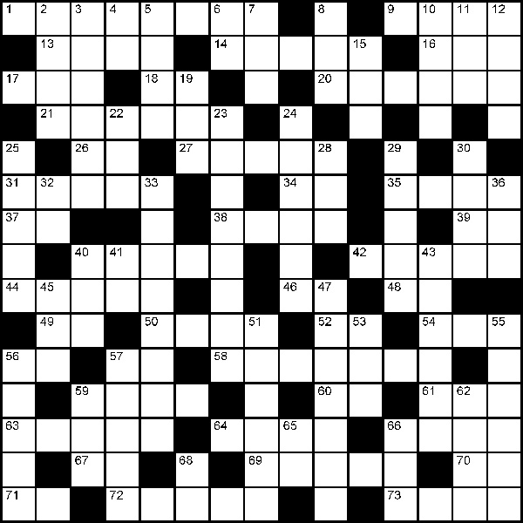

Across
1. This part of a pig is brushworthy
9. Live outside temporarily
13. Loosen a knot
14. Of the sun
16. Scary sound
17. IC whose leads lay flat on the PCB (abbr)
18. Plate current (abbr)
20. Charlotte's friend
21. Young pig
26. CW evening signoff
27. How meat is prepared for 58 Across
31. Pig sniffer
34. CW abbreviation for 'that'
35. Shallow digging for food
37. More than 1000 volts (abbr)
38. The curly part of a pig
39. Half of what makes a new line (abbr)
40. Contented pig sound
42. Pig's teeth
44. Synonym for runt
46. Hear .., Hear ..
48. What happens if you get caught cheating in the contest
49. Province that uses VE6 (postal code)
50. Where pigs grow
52. Battery energy units
54. Gets booed at the ball game
56. Before AD
57. Add M or A to get an elevation with respect to sea level
58. Don't watch this or politics being made
59. Colors
60. Registration mark (abbr)
61. Same as the mean
63. Cut common for both pork and lamb
64. Person from Oklahoma
66. Kitchen scraps fed to pigs
67. Large electrical manufacturer
69. Mistake
70. Propagation across the equator (abbr)
71. Our continent (abbr)
72. Meat baked in a pot
73. Where 72 Across is usually cooked
Down
2. Rear end of a pig
3. Deep blue
4. State that's home to Mt Rushmore
5. Work
6. VHF propagation via patches in the lower ionosphere (abbr)
7. Mother pig
8. Uncooked
10. Dear advice columnist
11. Written agreement (abbr)
12. Pig meat
15. Popular barbeque cut
19. A square one won't go in a round hole
22. Free software mascot
23. Pigs feet
24. Reputation of a pig
25. Queried
28. Logic family between RTL and TTL
29. Deceptive transaction
30. Pig's leg
32. Home of the Great Basin (postal code)
33. What pigs sniff out
36. Prefix of RadioShack computer
40. Ragchew
41. Roger Roger (abbr)
43. Agitated pig sound
45. Easiest DX award (abbr)
47. Part of the sky dawn first brightens
51. Where the little pig went
53. Sliced for sandwiches
55. Where pigs live
56. Breakfast pig
57. More than ultra
59. Another name for a pig
62. Make a political choice
65. Light waves used by remote control (abbr)
66. If there aren't enough chairs (abbr)
68. Multiply to get W

Solution to this month’s Puzzler
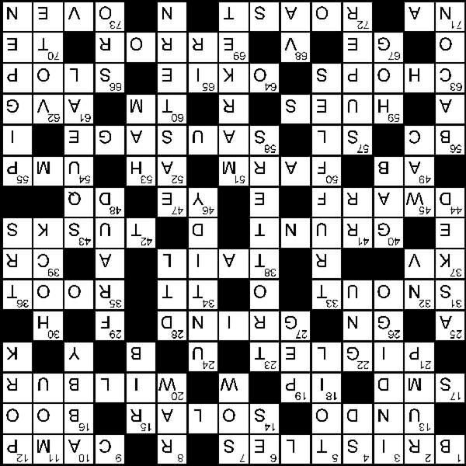

Rockwell-Collins
Amateur Radio Club
Mail Station 461-290
P.O. Box 833807
Richardson, TX 75083-3807

TO:

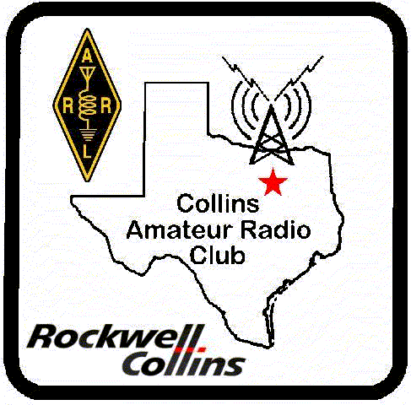 | CLUB STATIONS  (972) 705-1349  W5ROK REPEATER  441.875 MHz +5 MHz Input  131.8 Hz PL - RX and TX  W5ROK-1 PACKET BBS ROK Node  145.01 MHz
MEETING
Thursday 23 August 2007
17:30
Rockwell Collins Cafeteria

NEXT SIGNALS DEADLINE:
16 September 2007

